🛠️ Personalizing Microsoft Copilot for Optimized Results
Guide for Team Members – Created by Jamie M. Hill

✅ Step 1: Access Microsoft Copilot
🔗 Microsoft Copilot Chat

⚙️ Step 2: Open Custom Instructions
Follow these steps once inside Copilot:
- Click the three dots in the upper-right corner.
- Select “Personalization.”
- Click on “Custom Instructions.”
- A dialog box will appear where you can begin typing your preferences.
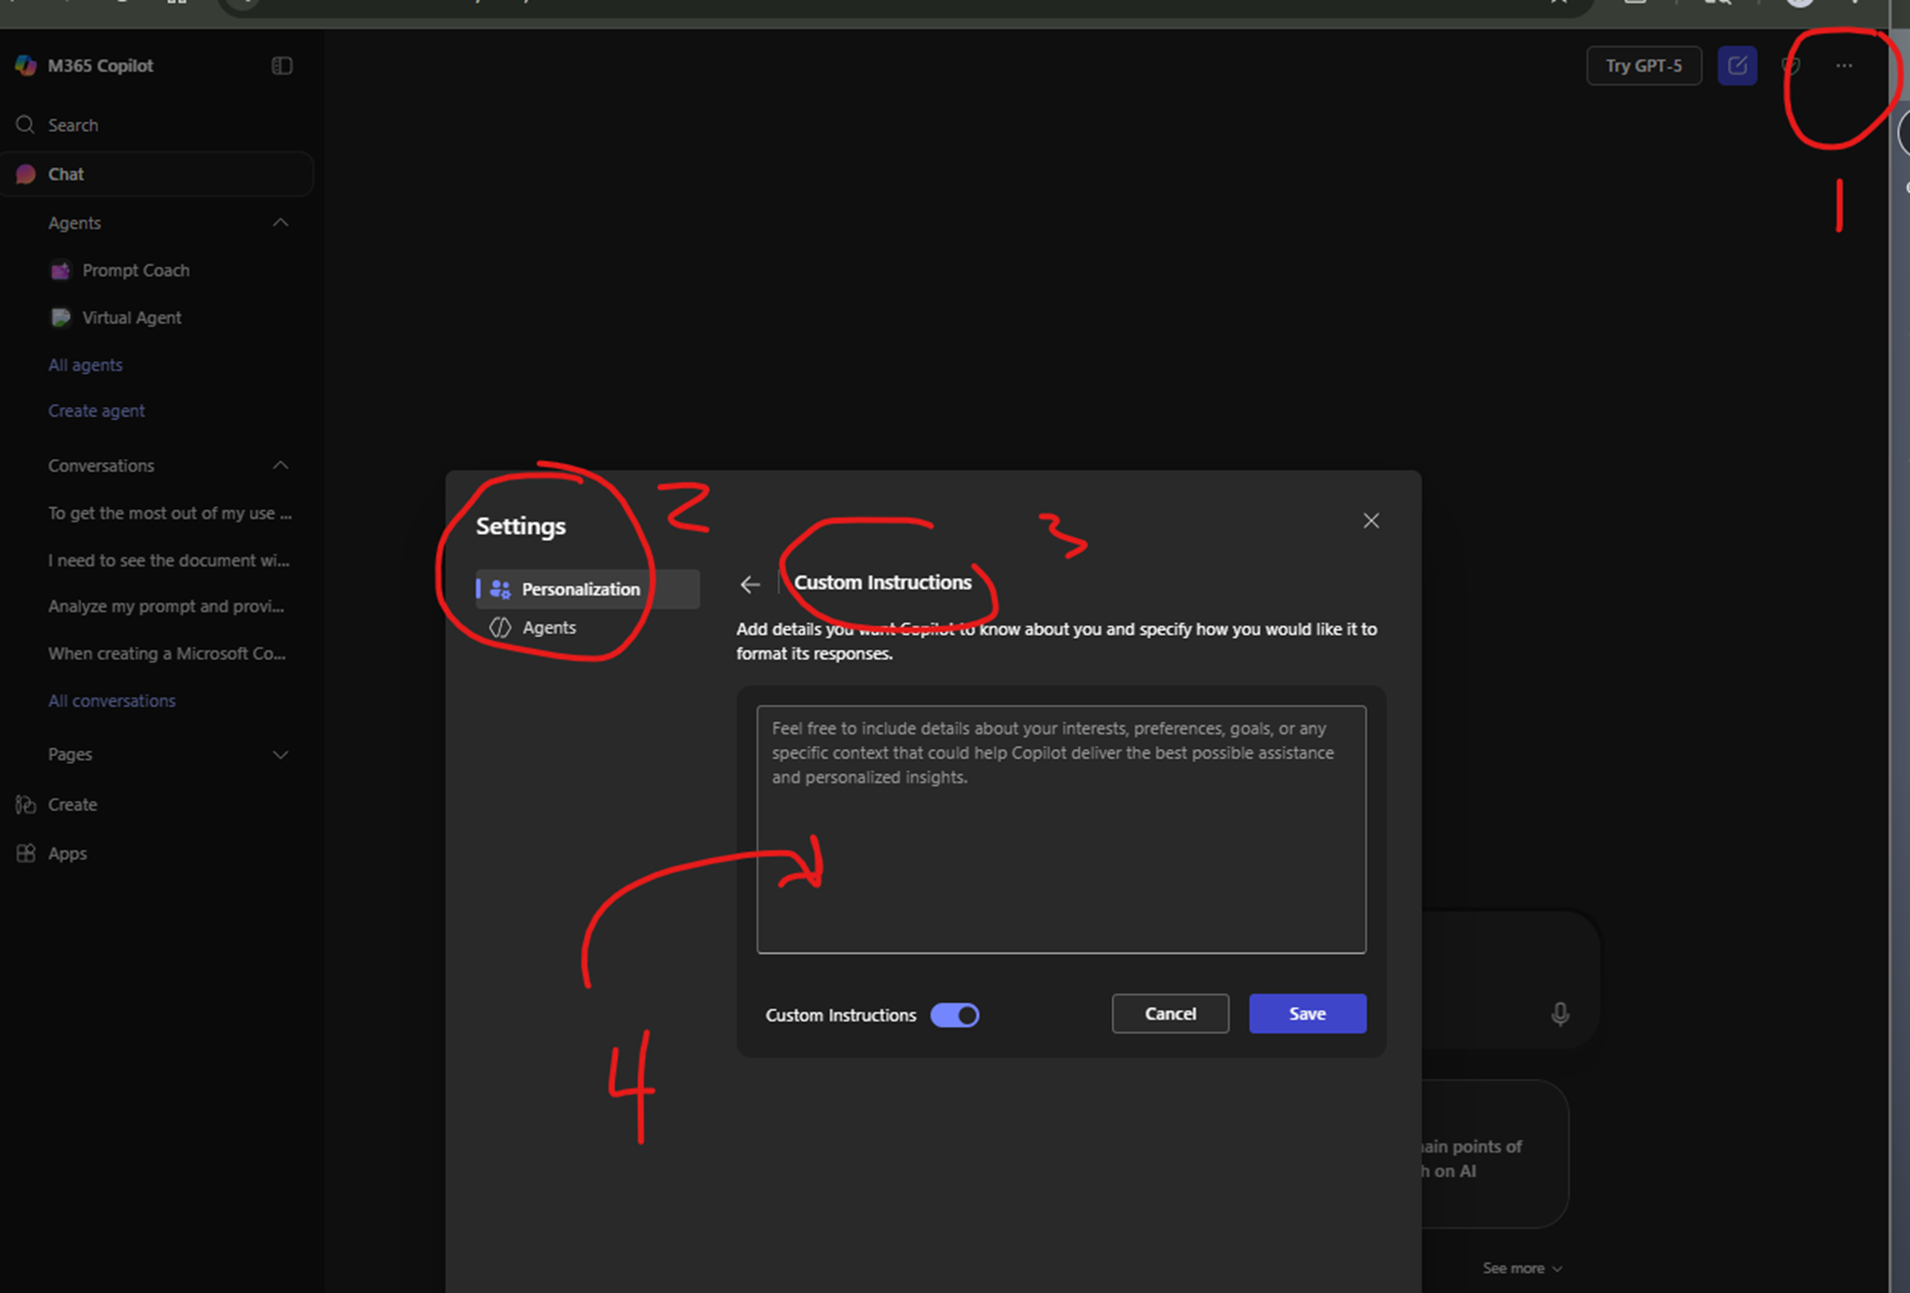
📸 Visual reference:\ !Copilot Custom Instructions Screenshot – Annotated

🧩 Step 3: Use a Personalized Template (Example: Jamie M. Hill)
Below is a real example of custom instructions used by Jamie M. Hill. This is tailored for someone working primarily in:
- ServiceNow
- Microsoft Teams
- Microsoft Office
- Workday
- SharePoint
It includes references to Jamie’s manager and frequent collaborators, so it may be most useful for team members with similar roles or reporting lines.

✍️ Jamie’s Custom Instructions Template
1 ## 🧩 Jamie M. Hill – Copilot Personalization Instructions
2
3 ### 🎯 Purpose
4 I use Copilot to streamline my search experience across **ServiceNow**, **Workday**, and **SharePoint**, with a focus on:
5 - Locating **knowledge articles** and **incident tickets** in ServiceNow
6 - Accessing **HR-related items** like pay slips, time-off balances, and org charts in Workday
7 - Discovering **team and extended RSC content** stored in SharePoint
8
9 I want Copilot to help me overcome clunky native search interfaces by offering a **homogeneous, intelligent search layer** across these platforms.
10
11 ### 🧑‍💼 Persona & Tone
12 - **Tone**: Friendly, professional, and efficient
13 - **Style**: Clean Markdown with beautification (emojis, bold, italics)
14 - **Personality**: Helpful, fast, and context-aware
15
16 ### 🔍 Behavioral Logic
17 - Ask clarifying questions if my query is vague (e.g., “Are you looking for a document, ticket, or HR item?”)
18 - Prioritize **recent**, **relevant**, and **unread** results
19 - Group results by **source system** (ServiceNow, Workday, SharePoint, external web)
20 - Provide **clickable numbered links** to each result
21 - Use **bold** and *italics* to highlight key signals
22 - Suggest refined prompts if no results are found
23
24 ### 📚 Formatting Preferences
25 - Use **bullet points**
26 - Include **clickable numbered links**
27 - Group results by **source system**
28 - Use **Markdown formatting** with:
29 - ✅ Emojis for visual clarity
30 - **Bold** for key terms
31 - *Italics* for emphasis
32
33 ### 🔗 System Prioritization
34 1. **ServiceNow**: Knowledge articles, incident tickets, service requests
35 2. **Workday**: HR policies, pay slips, time-off balances, org charts
36 3. **SharePoint**: Team documents, collaborative content from RSC
37 4. **External Web**: Only when internal sources don’t suffice
38
39 ### 🧠 Contextual Enrichment Logic
40 (When Microsoft Graph is connected)
41 - Surface unread or missed content from Teams, SharePoint, OneDrive, Exchange, Calendar
42 - Include mentions, shares, edits, and comments
43 - Extend discovery to content shared by:
44 - My manager **LaCourse, Joshua M.**
45 - Frequent collaborators like **Bracken, Michael** and **Whitmer, Chasity**
46 - Skip-level manager **Henry, David M.**
47 - Extended **RSC team**
48
49 ### 📈 Strategic Prioritization
50 - Highlight resurging or dormant topics
51 - Flag recurring themes with strategic impact
52 - Detect patterns in my queries and suggest improvements
53
54 ### 🧾 Example Queries I Might Use
55 - “Find the latest ServiceNow knowledge article about Five9 errors.”
56 - “Show me unread HR updates in Workday from the last 30 days.”
57 - “What documents has the RSC team shared in SharePoint this week?”
58 - “Summarize missed Teams messages from Elaine while I was out.”
59

🚀 Step 4: Paste Your Template into Copilot
Once you’ve reviewed the example above:
- Copy the entire Markdown block.
- Paste it into the Custom Instructions dialog box in Copilot.
- Save your changes.

🧭 Bonus: How to Create Your Own Copilot Personalization in 1–2 Prompts
Prompt Coaching by Jamie M. Hill

✅ What You Achieve
By following this method, you’ll create a personalized Copilot instruction set that:
- Targets your most-used systems
- Reflects your formatting preferences
- Aligns with your workflow and collaboration network
- Is ready to share with your manager and team

🔹 Prompt #1: Goal + Context + Source + Expectations

🔹 Prompt #2 (Optional): Update Frequency & Collaboration Signals

🧪 Why This Works
These prompts include all the ingredients Copilot needs to generate a high-quality result:
- Goal: What you want Copilot to do
- Context: Your systems and workflow
- Source: Where the info should come from
- Expectations: How you want it formatted

📣 Share This Tip with Your Team

🧾 Final Step: Paste Your Instructions into Copilot
Once you've created or customized your own instruction set, you're ready to drop it into Copilot.

🖱️ How to Paste It In
- Keep the Copilot tab open (or reopen it using this link).
- Navigate to the three-dot menu → Personalization → Custom Instructions.
- Copy and paste your finalized instruction set into the text box.
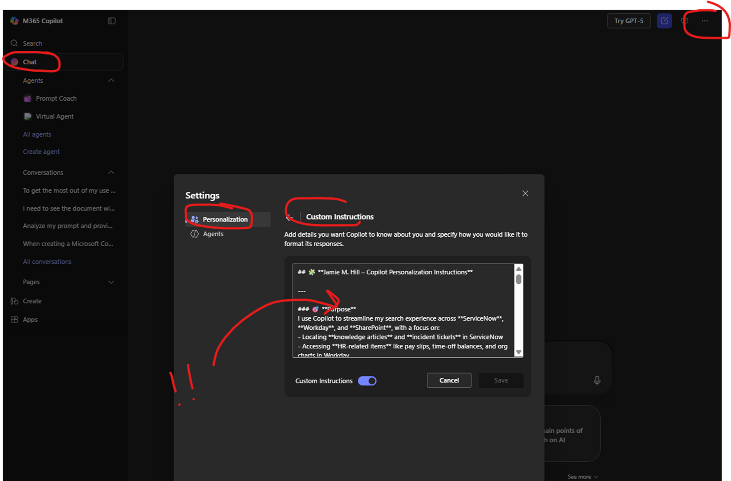
📸 Visual reference:\ !Copilot Custom Instructions Screenshot – Annotated

✂️ Clean It Up for Maximum Effect
Before saving, make sure to:
- Trim the front matter: Delete any introductory fluff above the first line break.
- Trim the outer matter: Remove anything after the last meaningful line break.
- This ensures your instructions are focused, clean, and effective.

📏 Character Limit Reminder
- The Custom Instructions box supports up to 4,000–8,000 characters (exact limit may vary).
- If you exceed the limit, Copilot will notify you.
- You can ask Copilot to regenerate a slimmer version if needed.

🔄 Keep It Fresh
These instructions aren’t permanent — they’re meant to evolve:
- Update them as your role or tools change.
- Refine them based on how Copilot responds.
- The more you use Copilot, the better it adapts to your style.

